**California Senate District 22**

The Honorable Kevin de Leόn

|  |  |  |
| --- | --- | --- |
| **Federal Historic Preservation Tax Incentive Projects in Los Angeles** | | |
| Certified Project  *Year represents Federal Fiscal Year | Use | Rehabilitation Costs |
| **2013** | | |
| Boyle Hotel | Affordable Housing | $ 7,600,000 |
| **2011** | | |
| 901 S. Broadway/Blackstone’s Department Store | Apartments | $ 34,000,000 |
| Metropolitan Building | Retail and Residential | $ 12,000,000 |
| **2010** | | |
| Southern California Gas Company Complex | Retail and Residential | $ 37,670,000 |
| Van Nuys Building | Retail and Residential | $ 15,000,000 |
| **2009** | | |
| Hosfield Building (Victor Clothing Company) | Retail and Residential | $ 8,000,000 |
| Pacific Electric Building | Apartments | $ 52,612,555 |
| **2008** | | |
| Judson Rives Building | Retail and Apartments | $ 16,200,000 |
| Pisgah Home District | Apartments/Community | $ 1,083,250 |
| Title Guarantee Building | Retail and Apartments | $ 29,500,000 |
| **2007** | | |
| Wm. G. Kerckhoff Bldg. & Annex | Apartments and Artist Lofts | $ 16,000,000 |
| Security Building | Apartments | $ 38,178,708 |
| Subway Terminal Building | Commercial and Housing | $ 55,175,744 |
| **2006** | | |
| Far East Cafe | Commercial and Senior Affordable Housing | $ 3,728,133 |
| Hellman Building | Multi-family Housing | $ 8,606,500 |
| Hotel Chancellor | Multi-family Housing | $ 4,530,000 |
| Santa Fe Freight Depot | School of Architecture | $ 9,640,362 |
| Young’s Market | Retail and Apartments | $ 8,000,000 |
| **2005** | | |
| 816 South Grand Avenue | Live/Work Spaces | $ 14,925,398 |
| Continental Building | Multi-Family Housing | $ 5,014,322 |
| General Petroleum Building | Apartments | $ 44,000,000 |
| Mortgage Guarantee Building | Apartments | $ 2,400,000 |
| Orpheum Theatre | Theater and Apartments | $ 9,900,000 |
| U.S. Post Office, Los Angeles Terminal Annex | Technology Center | $ 21,500,000 |
| **2004** | | |
| Gerry Building | Commercial | $ 4,600,000 |
| *Continued on next page* |  |  |
| *Federal Historic Preservation Tax Incentive Projects in Los Angeles, continued* | | |
| **2003** | | |
| San Fernando Building | Retail and Housing | $ 5,014,322 |
| **TOTAL REHABILITATION COSTS** (over years shown)  Attributed solely to the certified rehabilitation of historic structures | | **$ 464,879,291** |
| **TOTAL 20% Tax Credits Taken** (on the above projects) | | **$ 92,975,858** |

|  |  |
| --- | --- |
| **Certified Local Governments** | |
| Los Angeles | South Pasadena |

**Los Angeles Certified Preservation Tax Incentives Projects**

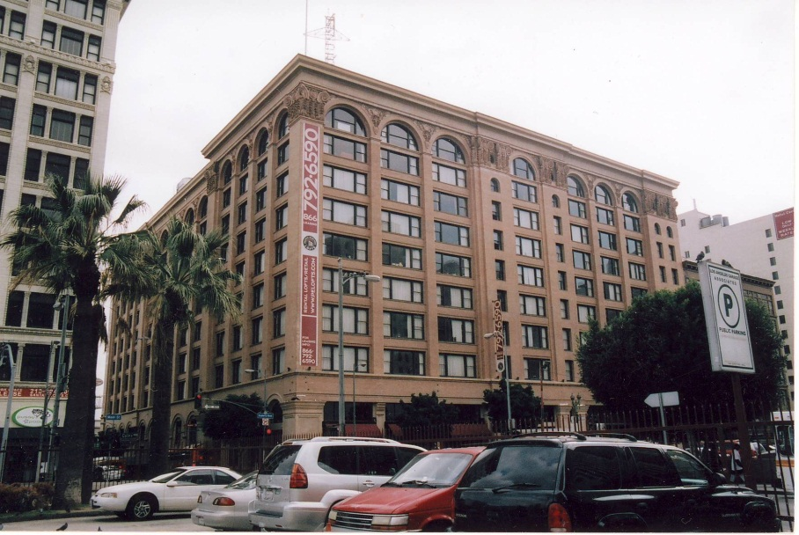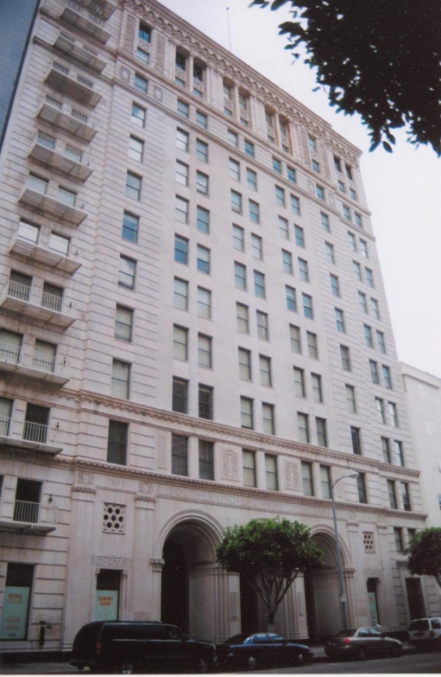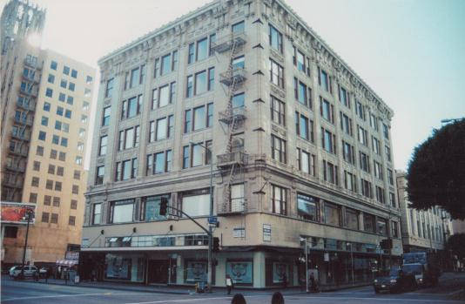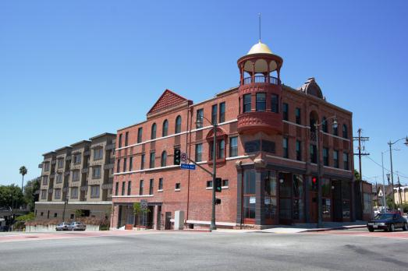**Boyle Hotel 901 S. Broadway**

**Southern California Gas Company Complex Pacific Electric Building**

**Los Angeles Certified Preservation Tax Incentives Projects**

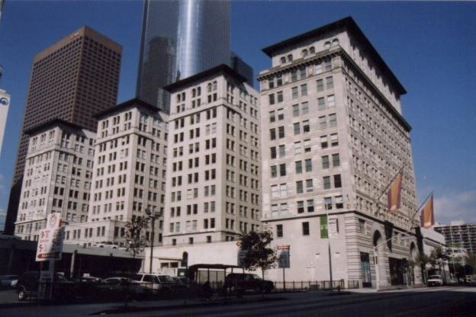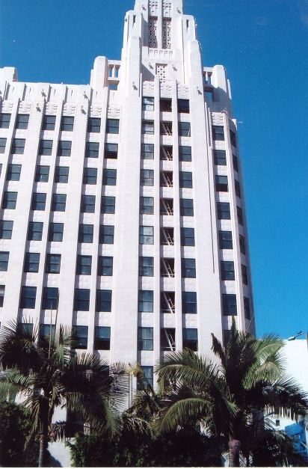

**Title Guarantee Building Subway Terminal Building**

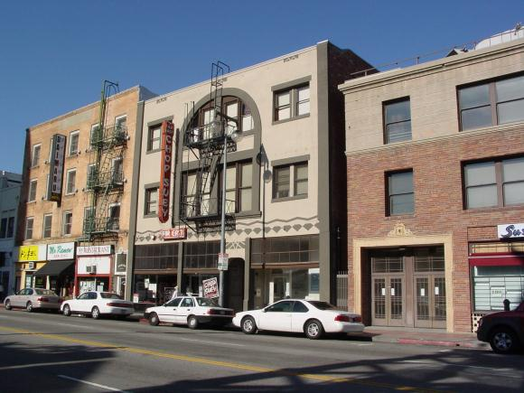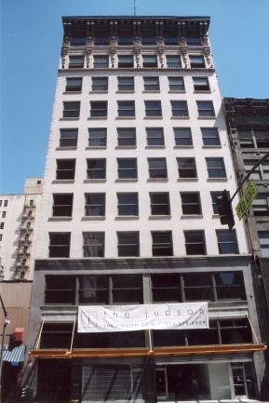

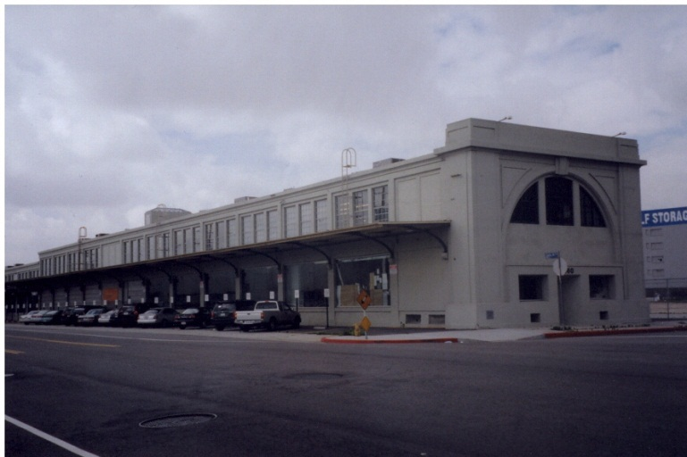**Judson Rives Building Far East Cafe**

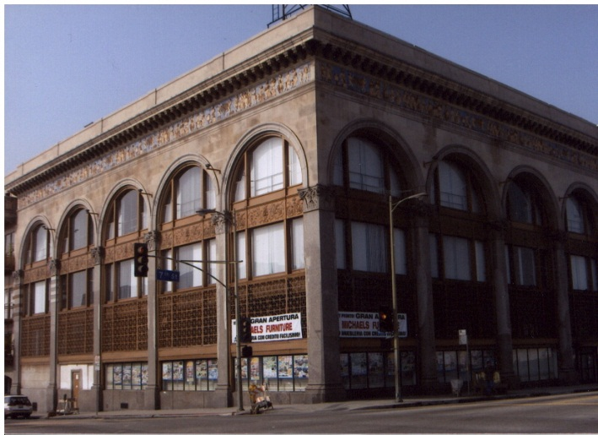**Young’s Market Sante Fe Freight Depot**

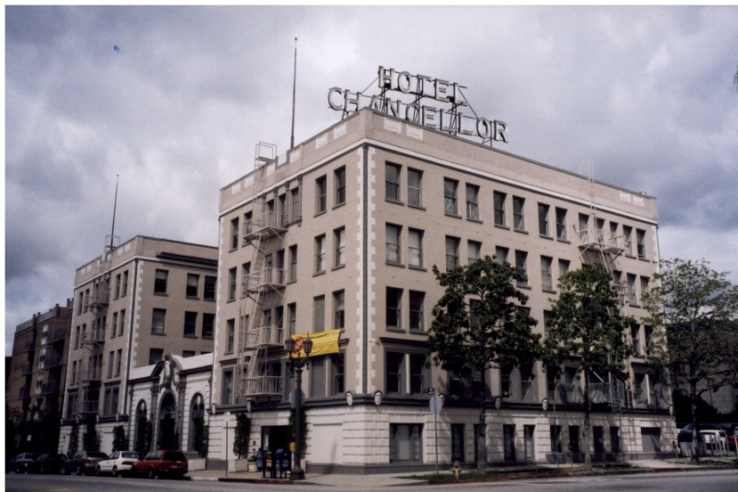**Los Angeles Certified Preservation Tax Incentives Projects**

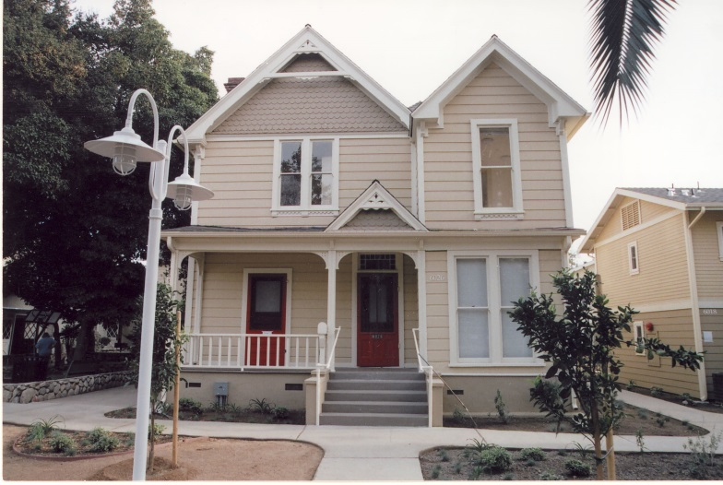 **816 South Grand Avenue Hotel Chancellor**

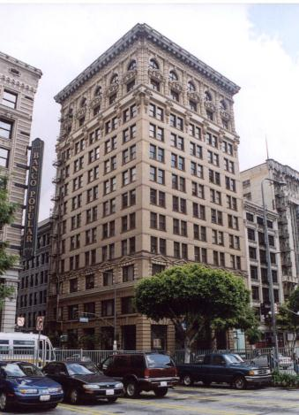

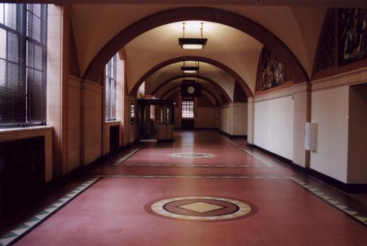

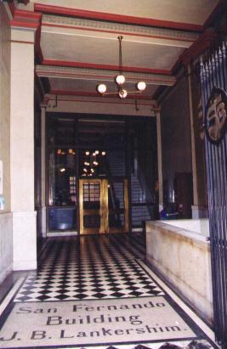 **Los Angeles Terminal Annex Continental Building**

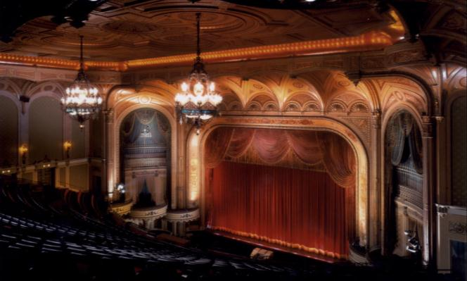 **San Fernando Building Orpheum Theatre**

For additional information on Certified California Tax Incentive Projects and Certified Local Governments see the Office of Historic Preservation website at [www.ohp.parks.ca.gov](http://www.ohp.parks.ca.gov)